**LAB WORK-09**

**01.Write a C Program to demonstrate pointer use (& and *) and Access Array Elements Using Pointers.**

**CODE:**

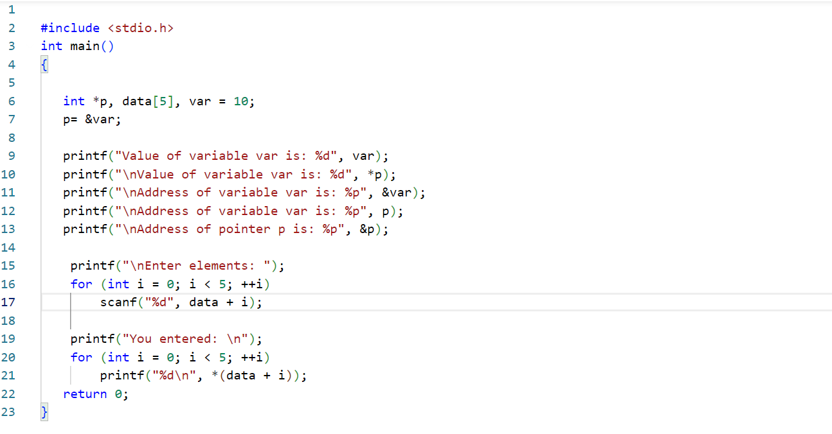

**OUTPUT:**

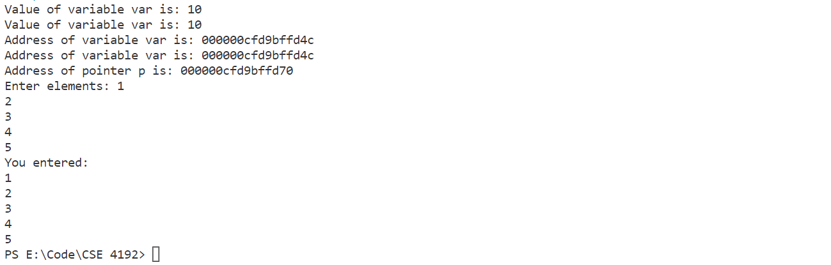

**02.Write a program to swap value of two variables and to find biggest among three numbers using pointer.**

**CODE:**

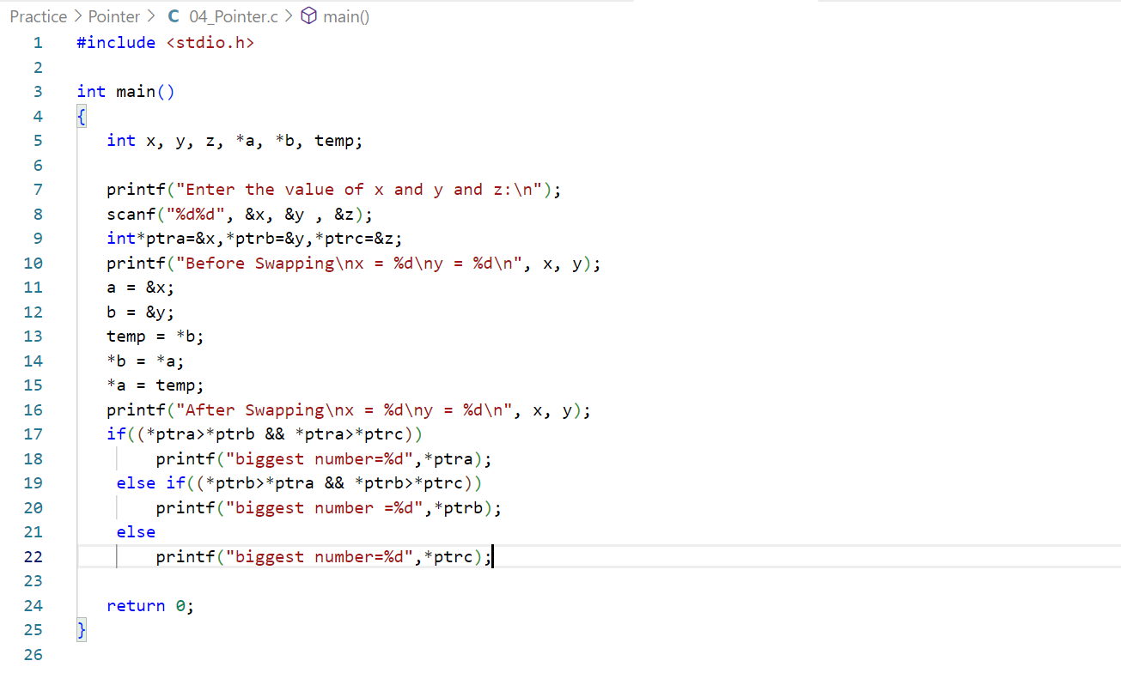

**OUTPUT:**

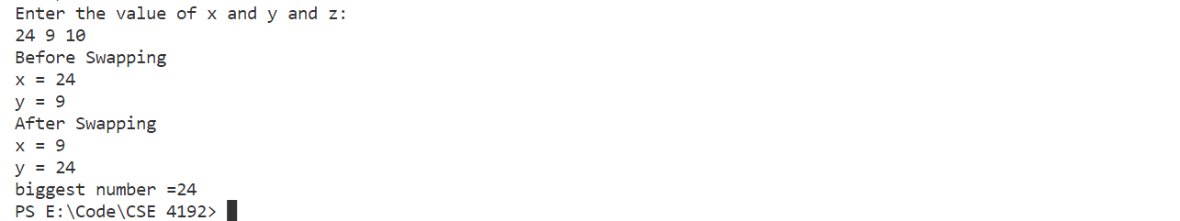

**03.Write a C Program to Create a file and write data into file n number of students name and marks.**

**CODE:**

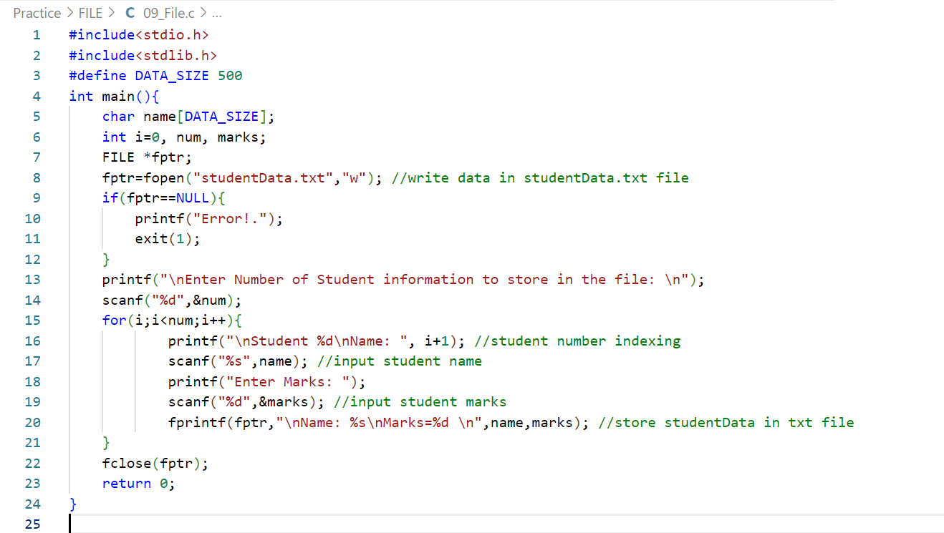

**OUTPUT:**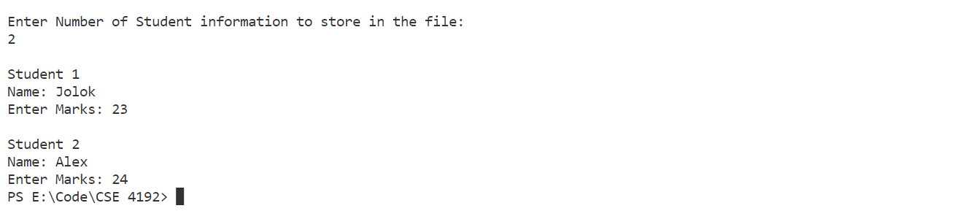

**FILE SAMPLE:**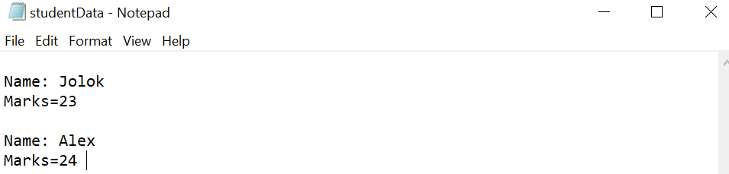

**04.Write a C Program to Create a file and read data into file n number of students name and marks and print in console.**

**CODE:**

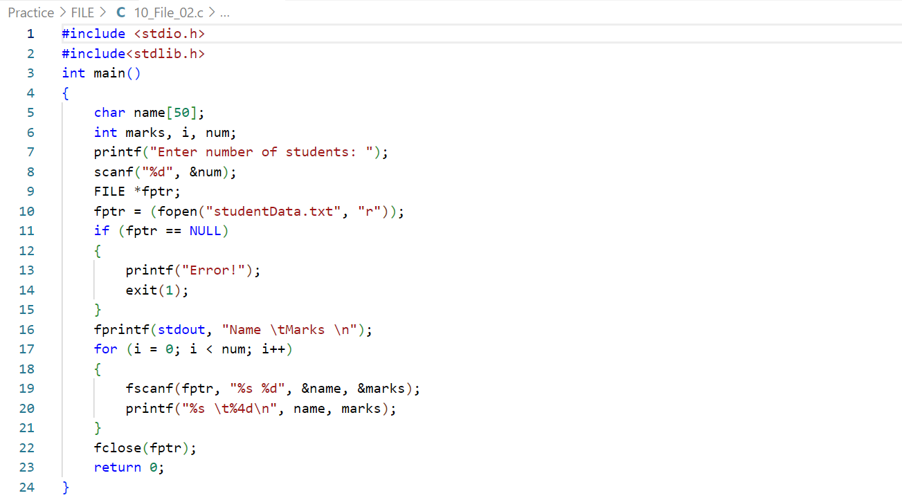

**OUTPUT:**

**FILE SAMPLE:**

